|  |
| --- |
| Capstone 2017 |
| Weight Lifting App |
| Instructions Manual |

|  |
| --- |
| Chris MacIsaac & Ash Julian  4-12-2017 |

Contents

Important Notes 2

Starting the Application 2

Coordinator Instructions 3

Logging in 3

Adding Participants 3

Deleting Participants 4

Resetting the Competition 4

Editing Participant Data 5

Timer Controls 6

Judge Instructions 7

Logging in 7

Voting 8

Participant Screen 10

Logging in 10

Information Displayed 10

# Important Notes

This web application stores all its data within cookies. It is not recommended to clear history while using this application. You should not use this application in incognito mode in a browser, and it won’t function correctly if you disable cookies.

All data is saved upon a text field losing focus so remember to click off a text field to save all data. You risk losing this data upon refresh if you don’t click off a text field after editing.

# Starting the Application

# Coordinator Instructions

## Logging in

Login credentials for the coordinator screen are as follows:

**User:**

**Pass:**

## Adding Participants

To add new participants to the competition, click the button designated by the arrow below.

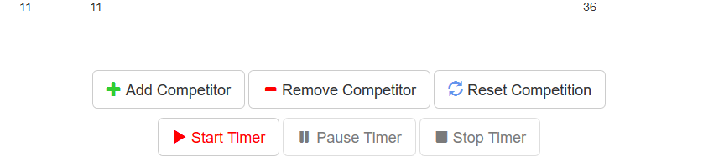

This will bring you to another view where you can enter data for the participant. If you need to leave a slot blank this will fill the slot in the spreadsheet with a blank area.

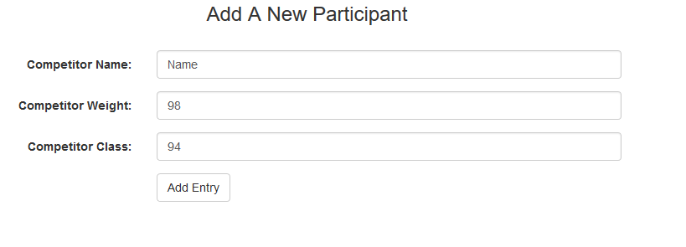

Upon clicking “Add Entry” your entry should be successfully added. (Do note that the class was left blank in this example.)

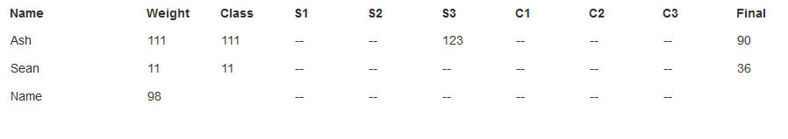

## Deleting Participants

To remove participants from the competition, select the appropriate button as shown by the blue arrow below.



This will bring you to a drop-down menu with all the participant’s names, select the participant you would like to remove and you will then be taken back to the main screen with the selected participant’s data no longer in the table.

Be careful when deleting, this is permanent and you can not get the data back.

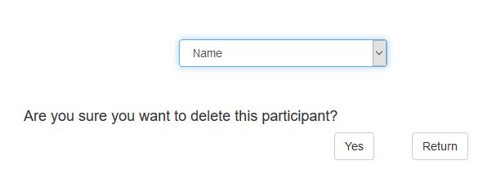

## Resetting the Competition

To quickly reset a competition and remove all data in the table, click on the reset button as shown by the arrow below.



**Be careful!** Make sure that you save your competition data (print it) before clicking this button as there is no way to get back the previous results!



This will clear all previous data.

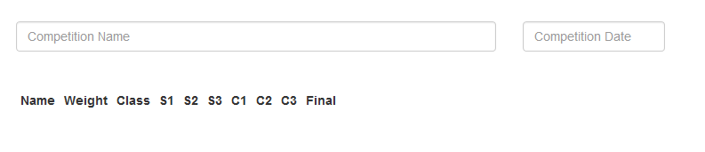

## Editing Participant Data

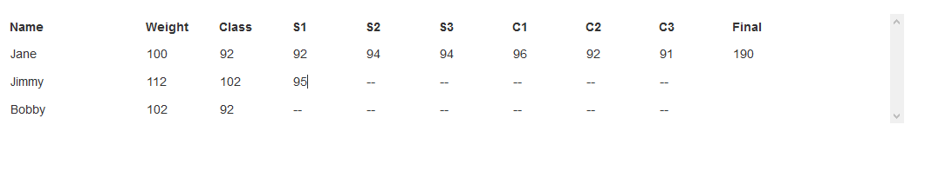

Editing participant data is as simple as clicking on a field and typing in the values. Each field is editable by the user.

Data is saved only when a user clicks off the field, so to save your data ensure that you’re doing this.

The final field is made for an equation of the highest values lifted, please enter an addition statement (92 + 96) and this field will complete the math for you when you click off the text field.

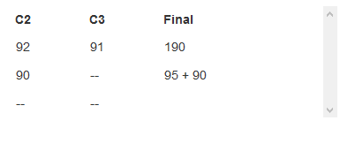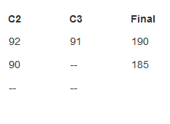

## Timer Controls

The timer is set to one minute by default, you can change this to two minutes (or back to one) by hitting the appropriate buttons.

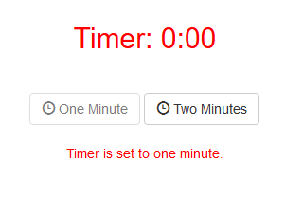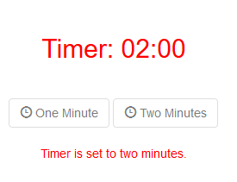

You are unable to change the timer’s duration while it’s active (buttons will be disabled). Please stop the timer to change the duration.

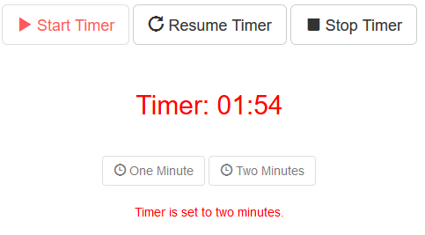

Timer controls are as follows:

Start – Starts the timer, also sends a signal to the judges that enables them to vote.

Pause – Pauses the timer.

Resume – Resumes the timer from the moment it was paused.

Stop – Stops the timer completely (you can no longer pause or resume).

Timer will beep every 30 seconds to let the competitor have an audible cue.

# Judge Instructions

## Logging in

Login credentials for the judge voting screen are as follows:

**User1:** judge1

**Pass1:** 123

**User2:** judge2

**Pass2:** 456

**User3:** judge3

**Pass3:** 789

## Voting

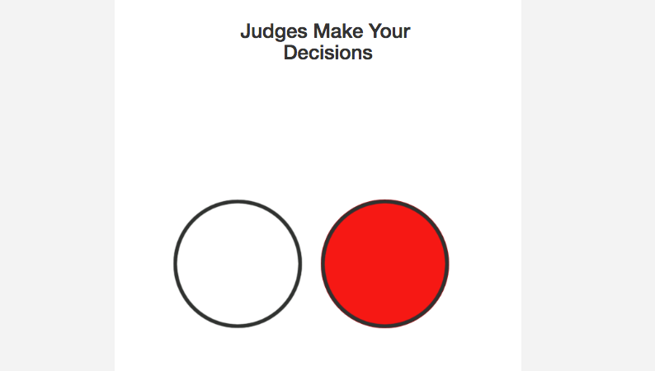

Judges will be taken to this screen to make their decisions but will be unable to place a vote until the coordinator enables their buttons. Upon enabling the judge can place their vote by clicking the appropriate button.

Clicking the white button designates a “Yes”.

Clicking the red button designates a “No”.

After a judge votes they will be taken to a waiting screen which will allow them to see in real time what the other judges have voted and if they have voted yet. Judges that haven’t voted are designated by a grey circle, judges that have voted yes or no will have their respective decisions displayed.

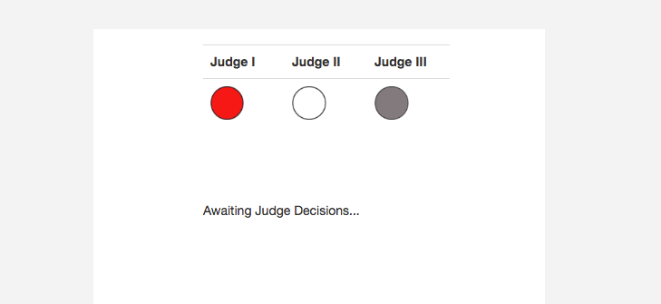

When a decision is made (two yes, or two no) a green down arrow is displayed so that the competitor can drop their weight.

This arrow is displayed regardless of whether all judges have voted or not.

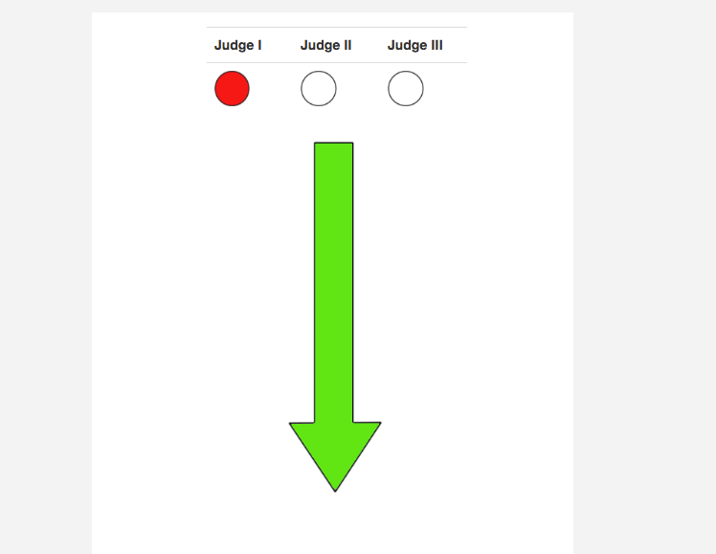

# Participant Screen

## Logging in

Login credentials for the participant screen are as follows:

**User:**

**Pass:**

## Information Displayed